**Subhan Bin Yousaf**

**Section B**

**481281**

**FOP Lab Manual 7**

**Lab Tasks**

**Task 1 :**

#include <iostream>

using namespace std;

int main(){

int arr [9];

int b;

for (int i=0;i<10;i++){

cout<<"Enter a number : "<<endl;

cin>>arr[i];

}

for (int i=0;i<10;i++){

cout<< arr[i] << "\t";

}

return 0;

}

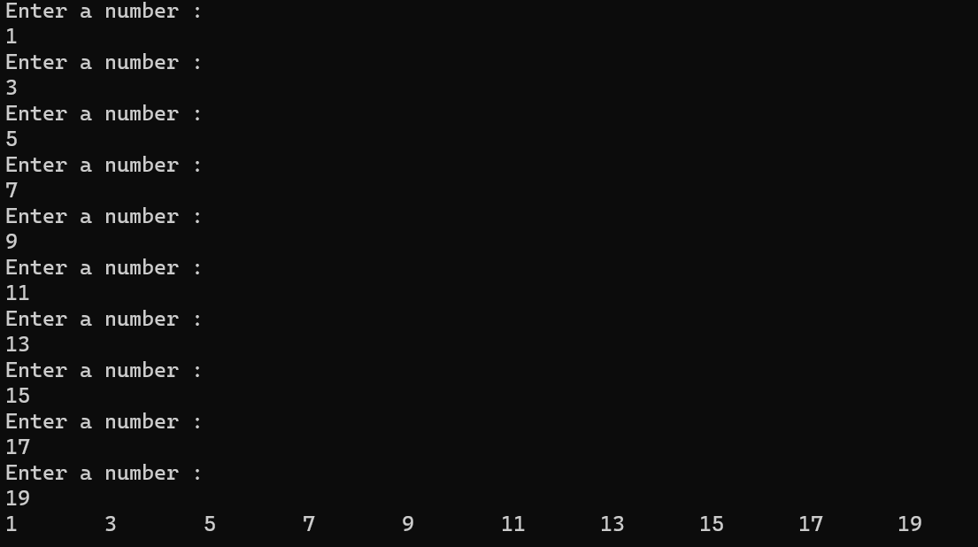

**Task 2 :**

#include <iostream>

using namespace std;

int main(){

int arr[5],a=0,b=1;

cout << "Enter values in array : ";

for (int i = 0; i < 5; i++)

{

cin >> arr[i];

}

for (int i = 0; i < 5; i++)

{

a = a + arr[i];

}

cout <<"The sum of the integers is : "<< a <<endl;

for (int i = 0; i < 5; i++)

{

b = b * arr[i];

}

cout << "The product of the integers is : " << b << endl;

}

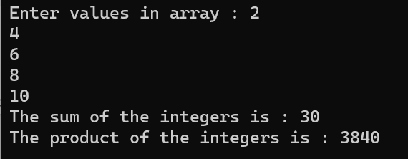

**Task 3 :**

#include <iostream>

using namespace std;

int main()

{

int size=9;

int half = size/2;

char arr[size];

for (int i = 0; i <= size-1; i++)

{

arr[i]=' ';

}

for (int i = 0; i <= half; i++)

{

for (int j = 0; j < size; j++)

{

arr[half - i]='*';

arr[half + i]='*';

cout<<arr[j];

}

cout<<endl;

}

for (int i = 0; i <= size-1; i++)

{

arr[i]='*';

}

for (int i = 0; i <= size; i++)

{

for (int j = 0; j < size; j++)

{

arr[size-i-1]= ' ';

arr[i]=' ';

cout<<arr[j];

}

cout<<endl;

}

return 0;

}

